

**MySQL to MySQL Flexible**

**CMF - Azure MySQL** **Single Server to Flexible Server - User Guide**

**For Script:**

**CMF-MySQL_Azure_SingleServer_to_Flexible.ps1**

**Document Summary**

|  |  |
| --- | --- |
| **Document Item** | **Current Value** |
| Document Title | CMF - Azure MySQL Single Server to Flexible server User Guide |
| Program | CSU Migration Factory |
| Date Last Modified | 03-JAN-2023 |
| Date Last Reviewed |  |
| Current Document Known Issue | N/A |
| Status | Initial |
| Document Description | This document provides the procedure/steps to execute the Automation script which helps to migrate Azure MySQL Single Server to MySQL Flexible servers. |

**Revision History**

This section represents the change history of the document. Revisions of the document must be tracked by identifying a new version number, the date it was modified, the person making the change, and the reason for the change.

|  |  |  |  |  |
| --- | --- | --- | --- | --- |
| Date | Version | Change Description | Author | Reviewer |
| 18-Dec-2023 | 1.0 | Initial Version | Madan Agrawal | Mukesh |

Table of Contents

1 Executive Summary 4

1.1 Objective 4

2 Prerequisites for MySQL Azure Single Server migration to Flexible server 4

2.1 Operating System Requirements 4

2.2 Software requirements 4

3 Executing the Script 4

3.1 Azure MySQL to Flexible server Migration execution 4

3.1.1 Creating support folders (Logs, Output, Downloads etc) 6

3.1.2 Validate Azure CLI 6

3.1.3 Azure MySQL Single Server and Flexible JSON output 8

3.2 Automation Script Transcript Log 8

3.2.1 Azure Portal authentication: 9

4 Preparing the INPUT CSV File 10

4.1 Input CSV File - **Azure_Subscription.csv** 10

4.2 Windows User credentials 12

4.3 Storage Space & Folder read write permission 13

4.4 Internet access 13

4.5 Internet access to the URLs below: 13

4.6 Without Internet access to the URLs 13

4.6.1 Installing Azure CLI 13

4.7 PowerShell Version & Execution policy 16

4.8 Connectivity 17

5 Post-import steps 17

5.1 Ensure a successful cutover 17

# Executive Summary

## Objective

This document provides the procedure/steps to execute the Automation script “CMF-MySQL_Azure_SingleServer_to_Flexible.ps1” which help to migrate the Azure MySQL Single Server to Flexible server.

# Prerequisites for MySQL Azure Single Server migration to Flexible server

## Operating System Requirements

* Supported Operating System

Windows 10, Windows Server 2012, Windows Server 2012 R2 and above

## Software requirements

* MySQL Client 5.6 and above
* PowerShell 5.1 version or higher.

# Executing the Script

## Azure MySQL to Flexible server Migration execution

* Create a folder MySQL-Single-to-Flexi (you may choose any available drive)
* Copy the provided “**script files and the folder Validation_Scripts**” under the folder created in the previous step. For example: If “MySQL-Single-to-Flexi” was the folder created in the previous step, then copy the Validation_Scripts & files under the MySQL-Single-to-Flexi Folder.
* Open windows Command prompt as **Administrator** and Change the working directory/folder to the folder (MySQL-Single-to-Flexi) where you created/copied the script files and folder in the previous step.
* Execute below command to Rename “rename.txt” file to “rename.bat” as below…

>rename rename.txt rename.bat

* Once renamed, Execute rename.bat on command prompt. This will change the extension of desired PowerShell script files from .txt to .ps1.

>rename.bat

* Enter the following command at the windows command prompt to trigger the CMF-MySQL_Azure_SingleServer_to_Flexible.ps1 script

**Powershell.exe -ExecutionPolicy RemoteSigned -File .\CMF_MySQL_Azure_Trigger.ps1**

### Creating support folders (Logs, Output, Downloads etc)

After triggering the automation all the support folders (Logs, Output, Downloads etc.) will be created automatically by the automation script in the “MySQL-Single-to-Flexi” folder..

### Validate Azure CLI

* Automation script validates the Azure CLI. If not found, automation will initiate installation.

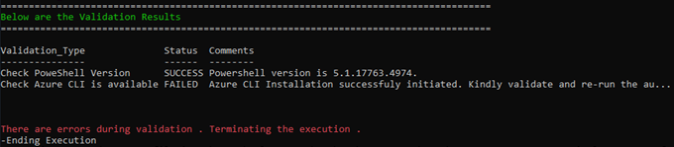

* Once Azure CLI Installation completes successfully and if you encounter the above error message, kindly close the Command Prompt and validate Azure CLI by re-running the automation script again.

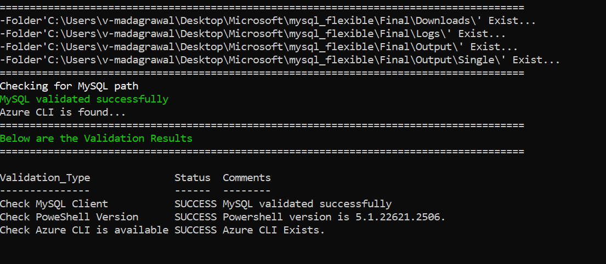

MySQL client, PowerShell version and Azure CLI are validated successfully.

* Once prerequisite module installation verified, script will list all the approved server and prompt for user input to continue for flexible server provisioning and migration as shown below…

Once confirmed by providing input ‘Y’ script will proceed to flexible server provisioning and migration. After processing all approved servers, script will display the final status table as below…

Note: Provisioning each flexible server can take from 5 mins to 30 mins for storage size less than 1 TB but can take more than 30 mins if size more than 1TB depending on the MySQL databases size on each server.

### Azure MySQL Single Server and Flexible JSON output

The Following resource JSON files will be generated in output folder for each Azure MySQL Single Server and Flexible MySQL server as below.



## Automation Script Transcript Log

Transcript will be generated in text format in Logs folder in below mentioned name

(.\Logs\CMF_MySQL_Azure_SingleServer_to_Flexible_Automation_Transcript_YYYYMMDDHHMMSS.txt)

### Azure Portal authentication:

* **Automation requires the Azure portal authentication:** script execution will require Azure portal authentication. During execution you need to provide the azure login credentials to proceed further as shown below…

# Preparing the INPUT CSV File

In Order to support the Info Gathering process, INPUT CSV FILE has been provided with Azure Subscription data.

**Each column will represent an Azure Subscription detail for MySQL** **Azure Single Server**

* Once the input file is prepared Copy the file (**Azure_Subscription.csv**) under the folder created in the previous step (C:\MySQL_Single)

## Input CSV File - **Azure_Subscription.csv**

**Important Notes:**

* This script is based on the csv file named ‘Azure_Subscription’ and the following columns in the Input csv file
* INPUT CSV FILE name must be **Azure_Subscription.CSV**
* **Column Name must be kept as shown below, change in names will result in errors**
* **Values in the column must be correct, incorrect values will also result in errors**

|  |  |
| --- | --- |
| **Column Name** | **Note** |
| **Tenant** | **Azure Subscription Tenant ID** |
| **Subscription_ID** | **Azure Subscription ID** |

|  |  |  |
| --- | --- | --- |
| **Seq.No** | **File** | **Note** |
| 1 |  | Sample: **Azure_Subscription.csv (Input File)** |
| 2 |  | Sample: **CMF-MySQL_Single_Server_Input_file.csv (Output File)** |

**Input File - CMF-MySQL_Single_Server_Input_file.csv CSV File**

Below table indicates which fields are mandatory to supply otherwise the script will fail. If you are not sure of destination flexible server size, please refer below link and look for section “Best practices for configuring Azure MySQL Import CLI command parameters”.

[Migrate Azure Database for MySQL - Single Server to Flexible Server using Azure MySQL Import CLI | Microsoft Learn](https://learn.microsoft.com/en-us/azure/mysql/migrate/migrate-single-flexible-mysql-import-cli)

|  |  |  |  |
| --- | --- | --- | --- |
| **Columns** | **Sample value** | **Mandatory** | **Description** |
| Host_Name | test-single-server | Yes | The name or resource ID of the source Azure Database for MySQL Single Server. |
| Resource_Group | test-rg | Yes | The name of the Azure resource group of the source Azure Database for MySQL Single Server. |
| Port | 3306 | No | Port number of MySQL Single, not require if default port 3306 |
| VCore | 2 | No | The number of vCores of the Source Azure Database for MySQL Single Server |
| Auth_Type | Mysql | No | Authentication Type |
| User_ID | Adminuser | Yes | The username for the administrator sign-in for your Source Azure Database for MySQL Single Server. |
| Password | Password | Yes | The Password for the administrator sign-in for your Source Azure Database for MySQL Single Server. |
| DB_Name | Mysql | No | Default database to connect. |
| Tenant | test.onmicrosoft.com | No | tenant Id |
| Subscription_ID | edf6dd9d-****-4bca-a997-***** | No | subscription_id |
| Approval_Status | No | Yes | Approved to migrate? - Yes/No. |
| SSL_Mode | PREFERRED | yes | ssl_mode Id – Preferred/disabled/required |
| SSL_Cert | C:\DigiCertGlobalRootG2.crt.pem | No | Default .\Validation_scripts\DigiCertGlobalRootG2.crt.pem |
| Destination | test-flexi-server | Yes | Enter a unique name for your target Azure Database for MySQL Flexible Server. The server name can contain only lowercase letters, numbers, and the hyphen (-) character. It must contain from 3 to 63 characters. Note: This server is deployed in the same subscription, resource group, and region as the source. |
| Tier | Burstable | No | Compute tier of the target Azure Database for MySQL Flexible Server. Accepted values: Burstable, GeneralPurpose, MemoryOptimized; Default value: Burstable. |
| sku-name | Standard_D2ads_v5 | No | Enter the name of the pricing tier and compute configuration for your target Azure Database for MySQL Flexible Server. Follows the convention {pricing tier}{compute generation}{vCores} in shorthand. See the pricing tiers for more information. |
| storage-size | 32 | No | The storage capacity of the target Azure Database for MySQL Flexible Server. The minimum is 20 GiB, and max is 16 TiB. The storage size for target flexible server should be equal to or greater than on the source single server. |
| admin-user | Adminuser | No | The username for the administrator sign-in for your target Azure Database for MySQL Flexible Server. It can't be azure_superuser, admin, administrator, root, guest, or public. |
| admin-password | Password | No | The administrator user's password for your target Azure Database for MySQL Flexible Server. It must contain between 8 and 128 characters. Your password must contain characters from three categories: English uppercase letters, English lowercase letters, numbers, and nonalphanumeric characters. |

## Windows User credentials

Windows users must have privileges to install the following software

* Azure CLI

## Storage Space & Folder read write permission

* Windows users must have the privilege to create folders and write the assessment results to that folder
* Minimum disk free space required is 1GB

## Internet access

* Connectivity must exist between the SYSTEM which runs the *“CMF-MySQL_Azure_SingleServer_to_Flexible.ps1”* Automation script and Azure Cloud.

## Internet access to the URLs below:

|  |  |
| --- | --- |
| **URL** | **Note** |
| <https://aka.ms/installazurecliwindows> | Azure CLI |

## Without Internet access to the URLs

**Note:** Follow the instructions below to download all the software manually to a server where internet connectivity is enabled. Once all the software is downloaded, move all of it to the server where *CMF-MySQL_Azure_SingleServer_to_Flexible.ps1* automation script will be executed and install all of them one by one.

### Installing Azure CLI

1. Paste the download link in web - https://aka.ms/installazurecliwindows



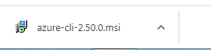

1. Launch the downloaded offline installer **azure-cli-2.50.0.msi** orlatest version at the time of download**.**

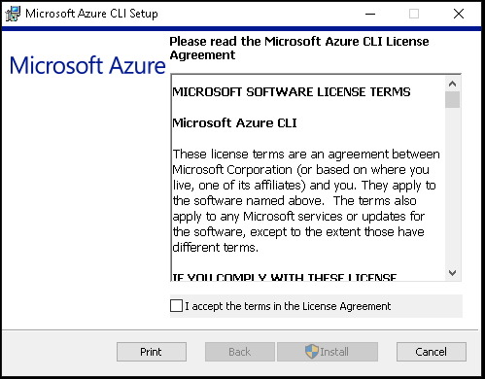

1. Read and accept the license terms.
2. Click on Install.

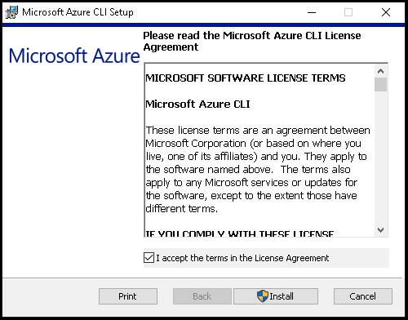

1. Azure CLI Installation is in progress

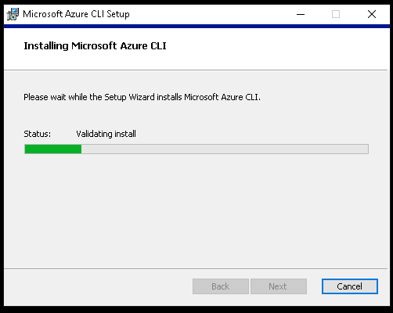

6. Once the installation is complete, click on Finish

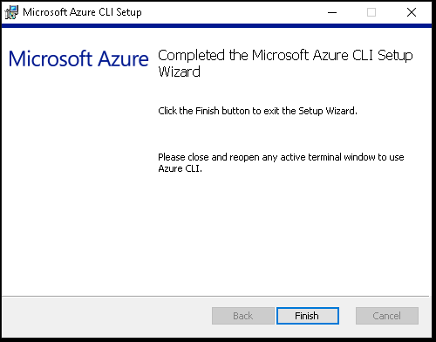

## PowerShell Version & Execution policy

Execute the below commands from windows PowerShell as Administrator.

1. To find the PowerShell Version

* Get-Host

1. Set the PowerShell execution policy

* **Set-ExecutionPolicy Unrestricted -Scope CurrentUser**



## Connectivity

* Connectivity must exist between the SYSTEM which runs the Azure MYSQL Single Server to Flexible Automation script and Azure Cloud.

# Post-import steps

* Copy the following properties from the source Single Server to target Flexible Server post MySQL Import operation is completed successfully:
  + Read-Replicas
  + Monitoring page settings (Alerts, Metrics, and Diagnostic settings)
  + Any Terraform/CLI scripts you host to manage your Single Server instance should be updated with Flexible Server references.

## Ensure a successful cutover

To ensure a successful cutover, perform the following tasks:

1. Configure the appropriate server-level firewall and virtual network rules to connect to target Server. You can compare the firewall rules for the source and [target](https://learn.microsoft.com/en-us/azure/mysql/flexible-server/how-to-manage-firewall-portal#create-a-firewall-rule-when-creating-a-server) from the portal.
2. Configure appropriate logins and database level permissions in the target server. You can run SELECT FROM mysql.user; on the source and target servers to compare.
3. Make sure that all the incoming connections to Azure Database for MySQL Single Server are stopped.

You can set the Azure Database for MySQL Single Server to read only.

1. Ensure that the replica has caught up with the primary by running show slave status \G and confirming that the value for the Seconds_Behind_Master parameter is 0.
2. Redirect clients and client applications to the target instance of Azure Database for MySQL Flexible Server.
3. Perform the final cutover by running the mysql.az_replication_stop stored procedure, which will stop replication from the replica server.
4. Call mysql.az_replication_remove_master to remove the Data-in replication configuration.

At this point, your applications are connected to the new Azure Database for MySQL Flexible server and changes in the source will no longer replicate to the target.

# Appendix:

* + 1. MySQL Import command maps over the corresponding tier, version, sku-name, storage-size, location, geo-redundant-backup, public-access, tags, auto grow, backup-retention-days, admin-user and admin-password properties from Single Server to Flexible Server as smart defaults if no inputs are provided to the CLI command. We can chose to override the smart defaults by providing inputs for these optional parameters.
    2. If we want to override smart defaults, select the compute tier and SKU name for the target flexible server based on the source single server’s pricing tier and VCores based on the detail in the following workbook.



Ref: [Migrate Azure Database for MySQL - Single Server to Flexible Server using Azure MySQL Import CLI | Microsoft Learn](https://learn.microsoft.com/en-us/azure/mysql/migrate/migrate-single-flexible-mysql-import-cli)

[Tutorial: Migrate Azure Database for MySQL – Single Server to Azure Database for MySQL – Flexible Server with open-source tools | Microsoft Learn](https://learn.microsoft.com/en-us/azure/mysql/migrate/how-to-migrate-single-flexible-minimum-downtime)